CONTEXT LEVEL DIAGRAM

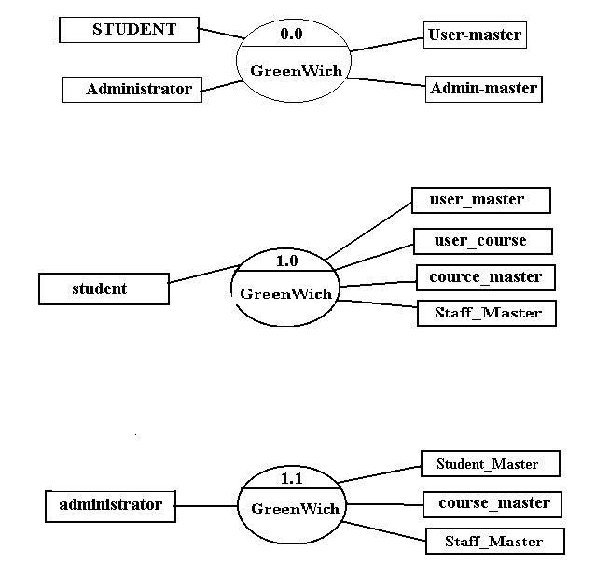

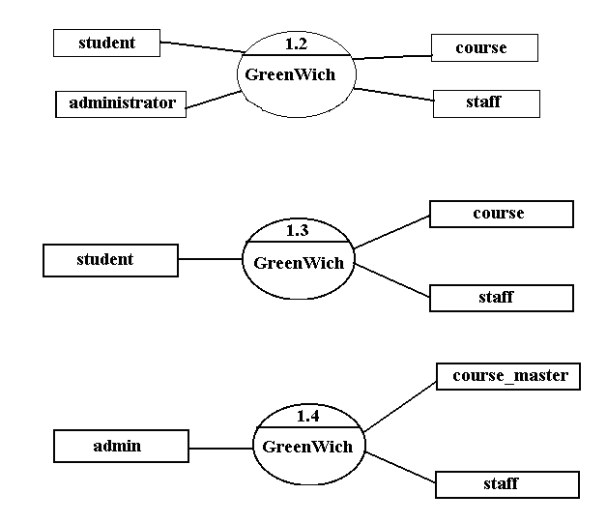

E – R DIAGRAMS.

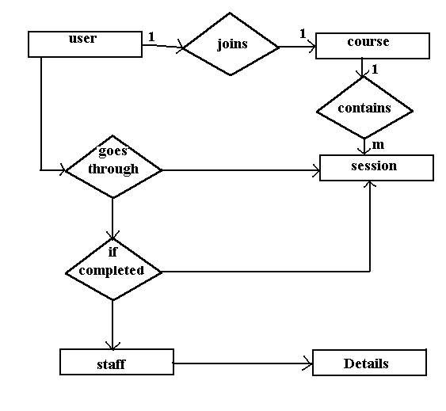

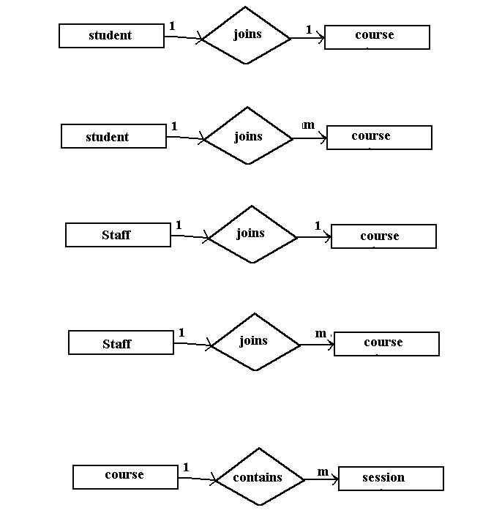

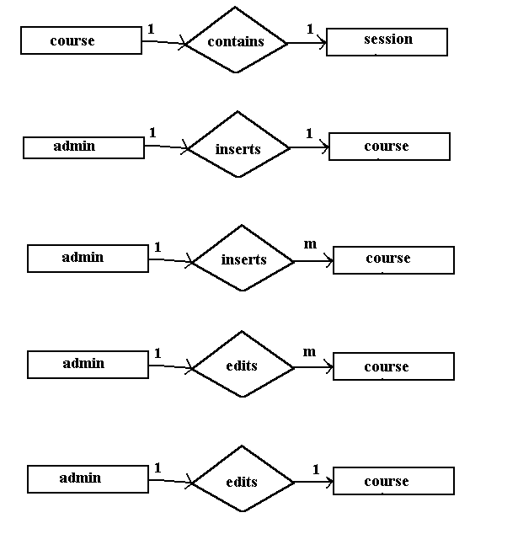

DATA DICTIONARY.
Database Design:

T_Admin



T_CourseReg



T_Courses



T_Emp_Personal

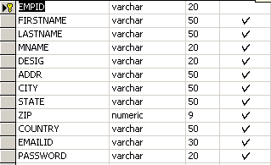

Staff_Master

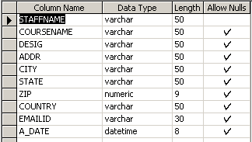

INTRODUCTION

- Scope. Developing an e-learning initiative is a typically much larger endeavor than that of an instructor-led training (ILT) program. Consider the increased expenses, number of people involved, development time, technological requirements, and delivery options.
- Interdependence. It's possible, even common, for an ILT program to be conducted without the knowledge of anyone but the participants, their immediate managers, and the training provider. In contrast, even the smallest e-learning program requires a wider group of people. Ranging from (at a minimum) representatives from the IT and HR departments to (more commonly) an organization-wide task force, the scope of the project often dictates that there are more decision makers, more stakeholders, and more links between previously unrelated departments.
- Visibility. When a traditional training program goes bad, a participant's dissatisfaction is usually voiced by word of mouth. And the people who express dissatisfaction, in most cases, are the participants and, maybe later, the people directly affected by their work. Again, due to the scope of the undertaking (especially the high budget and number of resources required), the efficacy of an e-learning program will be delivered to a larger group of people and through a wider variety of channels than an ILT program. Typically, a CEO can tap into a training database and view participants' course comments, exam results, and the courses taken. It's easier to determine whether an e-learning program is unpopular or ineffective than to rely on word of mouth about a questionable ILT program.
In order for a needs assessment to have a successful outcome, it must accomplish many things--improving performance being just one. It must also
- determine how to achieve the high-level goals of the organization (such as increasing sales and fostering innovation)
- determine what system obstacles (other than training) need to be removed
- point to an intervention that will balance the conflicting needs of different stakeholders (IT versus HR, participants versus managers, budget versus vendor costs, and so on)
- pave the way for a new program.
Organizations implementing e-learning programs need to expand the usual needs assessment process by creating a high-level requirements document that includes
- objectives (macro organizational objectives and micro target learner population objectives)
- an e-learning readiness score
- a list of advantages and potential obstacles to e-learning adoption
- a list of possible e-learning configurations.
Technology Used:
- Java
- Servlets
- Oracle
Operating System:
  - Windows

MODULES

- Administration
- Content Management
- Evaluation

MODULE DESCRIPTION

Administration:

- User Information
- Uploading the content permanently
- Uploading the content temporally
- Removing the content permanently
- Removing the content temporally
- Working options
  - Caching Feature
  - Content length for each Category

Content Management
These are the pages that are associated with the logic pages, and contain content specific to that page.

Organizing the topics according to the category
- Organizing the subtopics according to the subcategory

- Providing appropriate links to specified category

- A mechanism to export and import data from and to XML files

- Generating maps for specific category

- Providing a quiz after completion of specified course

Evaluation

- Preparing the question paper randomly according to the category
- Spot result evaluation
- Specifying level of evaluation

